Shipping & Receiving Management Application

CIS 260 | Software Engineering Project

USer Manual

Kalin Bowden & Jesse Fender

2018

**Shipping & Receiving Management Application**

**User Manual**

**Kalin Bowden & Jesse Fender**

**Software Engineering Project • CIS 260 • 2018**

**TABLE OF CONTENTS**

|  |  |
| --- | --- |
| Introduction | 6 |
| Getting Started   1. *Installing the Application* 2. *Logging in for the First Time* | **8**  *8*  *8* |
| Receiving Freight   1. *Getting to Know the Receiving Form* 2. *How to Receive a Package* 3. *Editing an Existing Package* 4. *Deleting an Existing Package* 5. *Printing a Delivery Log* 6. *Searching Daily Receiving List* 7. *Refreshing the Grid* | **13**  *13*  *14*  *15*  *16*  *16*  *17*  *17* |
| History   1. *Getting to Know the History Form* 2. *Adding a Package to the Daily Receiving List* 3. *Printing History* 4. *Refreshing the Grid* 5. *Searching History* | **18**  *18*  *18*  *18*  *19*  *19* |
| Manage   1. *Getting to Know the Manage Screen* 2. *Creating a User* 3. *Roles* 4. *Adding an Item to a List* 5. *Editing an Item in the List* 6. *Deleting an Item in the List* 7. *Printing a Table* 8. *Sorting a Table* 9. *Searching a Table* | **20**  *20*  *21*  *21*  *22*  *22*  *22*  *23*  *23*  *23* |
| Notes   1. *Using Notes* | **26**  *26* |
| Settings   1. *Getting to Know the Settings Menu* 2. *Connecting to a Database* 3. *Backing Up the Database* 4. *Automatic Backup Schedule* 5. *Manual Backups* 6. *Restoring the Database* | **28**  *28*  *28*  *29*  *29*  *30*  *30* |
|  |  |
|  |  |

**INTORDUCTION**

This application is specifically designed to allow Ozarks Technical Community College’s Shipping and Receiving Management Office to accurately and efficiently receive, track, and distribute freight throughout the college and its campuses. Using a remote database this application stores package information as well as other information important to the daily task of receiving and delivery. Creating reports, delivery logs, and data reports are made easily through the various menus and interfaces offered by the application.

**GETTING STARTED**

**Installing the Application**

If you need to install or reinstall this application, please contact your software or database administrator.

**Logging in for the First Time**

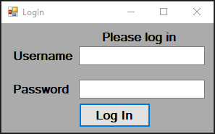Once the application starts, you will be prompted to login (see fig 1.1). For first-time setup use the username and the passwordprovided by your database administrator.

Fig 1.1

After successfully logging in, the Main Menu will load (see fig 1.2). You will be presented with four options: Receiving, History, Manage, and Settings. To complete initial setup, click Settings (see fig 1.2).

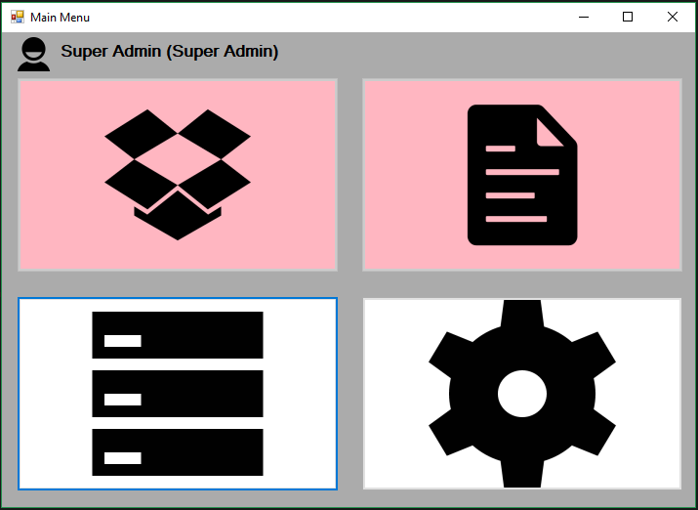

Fig 1.2

Switch User

Manage

Settings

In the Settings menu, you will need to enter the database connection information. To get this information contact your database administrator. Once you have entered the connection information, test the connection by pressing the test connection button (see fig 1.3). If the connection is successful, a pop-up with “Connection Successful” will display. If the connection fails, contact the database administrator. After the connection success message displays, use the Save Connection button (see fig 1.3) to save the connection information. When you click the Save Connection button the application will restart so that the database connection can be applied through-out the application.

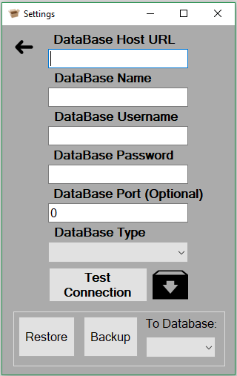

Test Connections

Save Connections

Fig 1.3

After the application restarts, you will need to add a User with administrative privileges. To start this process login with the username and password provided to you by your database administrator. In the Main Menu, click Manage (See fig 1.2). Once in the Manage menu, click the User button (see fig 1.4) to select the User Data Table.

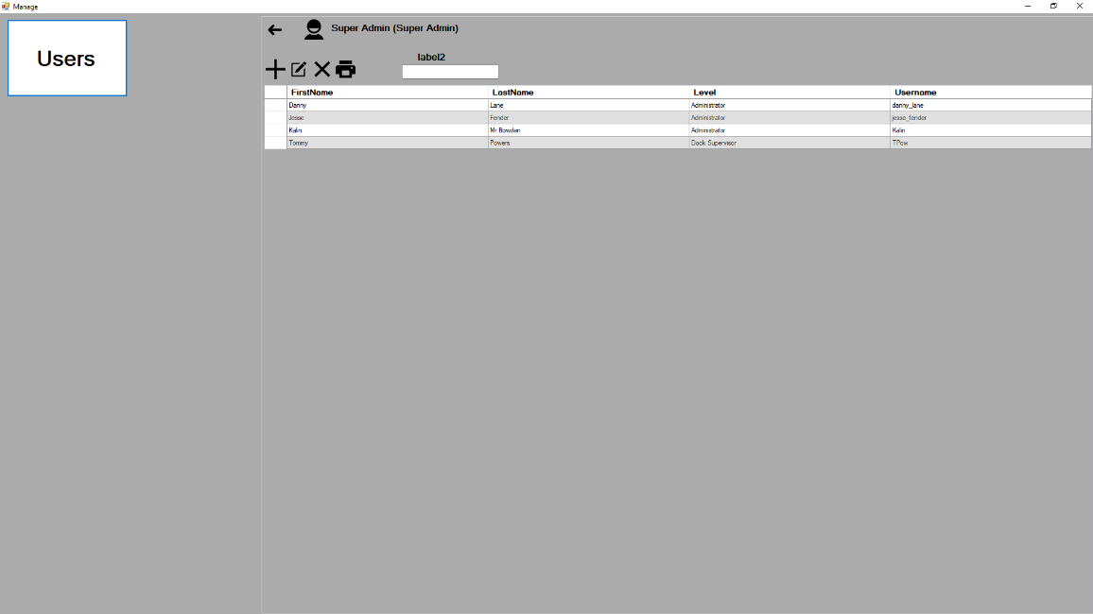

User Button

Fig 1.4

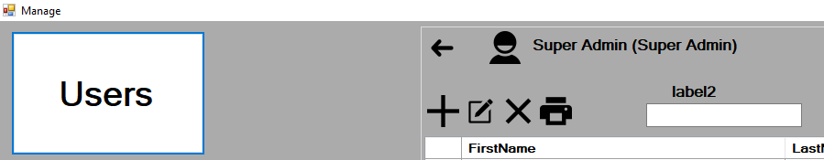

Fig 1.5

User Button

Back to Main Menu

Add

After selecting the User table, click Add to add a user (see fig. 1.5). The Add User window will display (see fig. 1.6).

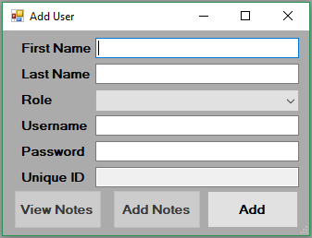

Fig 1.6

Fill each field with the requested information. Its important, that when adding a User for the first time, that the “Administrator” role be selected so that the user will be able to access all functions. Once all fields have been filled, click the Add button to create the User.

Click the Back button to return to the Main Menu (see fig. 1.5). In the Main Menu, click the Switch User icon (see fig. 1.2) to bring up the Login form (see fig. 1.1). Log in as the User you created to complete the First Time Setup.

**RECEIVING FREIGTH**

**Getting to Know the Receiving Form**

The receiving form is the main form for the application. From here you can receive packages, assign clerks, create delivery logs, and much more.

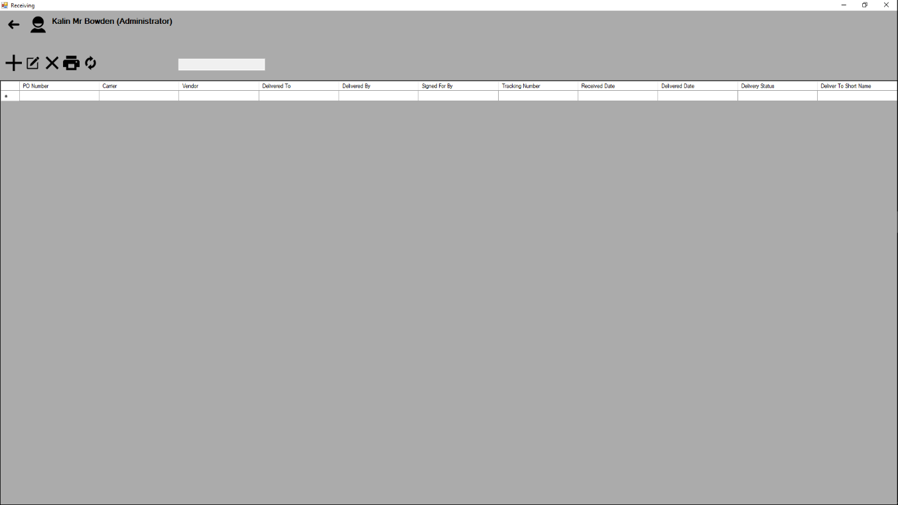

Fig 2.1

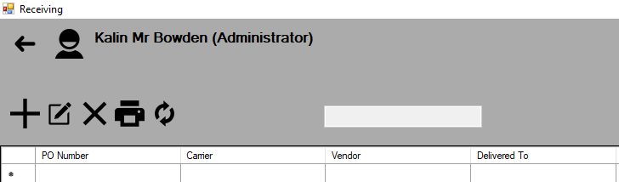

Fig 2.2

Print

Delete

Add

Search

Refresh

Edit

Back

Fig 2.3

Select All



Data Columns

Cells

Data Rows

**How to Receive a Package**

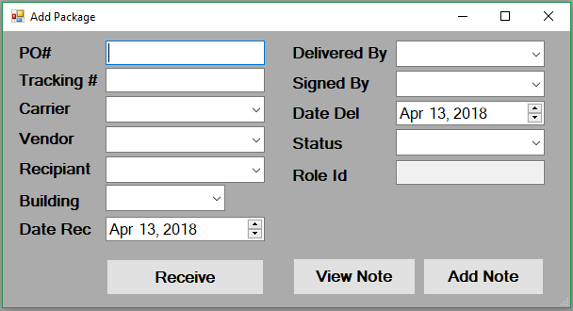To add a package to the daily receiving list, click the Add button (see fig 2.2) to display the Add Package Form.

Fig 2.4

Fill all the required fields with the necessary data. At a minimum a Package needs a Tracking Number, Carrier, Vendor, Recipient, Building, and a Date Received. Click Receive to receive the Packages (see fig. 2.4).

**Editing an Existing Package**

To edit an existing Package, Click the row to highlight the selected package (see fig 2.3). In the menu click the Edit button (see fig. 2.5) to display the Edit Package Form.

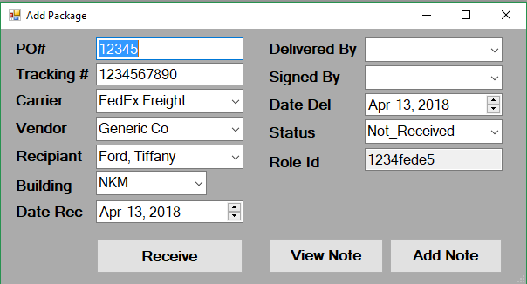

Fig 2.5

Change the fields as needed and click Receive (see fig 2.5). The package will be updated with the new information.

**Deleting an Existing Package**

To delete a package, select the row you wish to delete. Click the delete button to remove it from the database (see fig 2.2). It should be noted that packages that were created before the current day will not be able to be deleted.

**Printing a Delivery Log**

To print the daily log list, select the row(s) you wish to add to the log. Click the Print button (see fig 2.2). The Print Preview will display with the selected rows (see fig 2.6). Select a clerk from the list and push print (see fig 2.6). Follow the on-screen directions for printing on your specific computer.

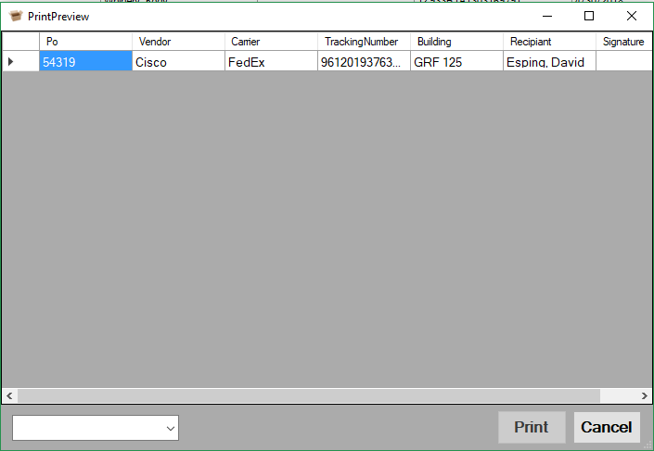

Fig 2.6

Select Clerk

Once you have successfully printed the log, the selected rows will update with the clerk name, delivery status to “Out for Delivery”, and delivery date.

**Searching Daily Receiving List**

To find packages more quickly you can search for packages. To do this, first double click the column you wish to filter by. A label will appear to indicate the selected column you are filtering by. In the search text box (see fig 2.2), type in the value you are looking for. The list will filter as you type text into the textbox.

**Refreshing the Grid**

Should you experience a delay in the list updating or need to refresh the list, click the refresh button (see fig. 2.2) to reload the list.

**HISTORY**

**Getting to Know the History Form**

The History Form is where you can view previously received packages as well as add them to the daily receiving list

Fig 3.1

Search Box

Back

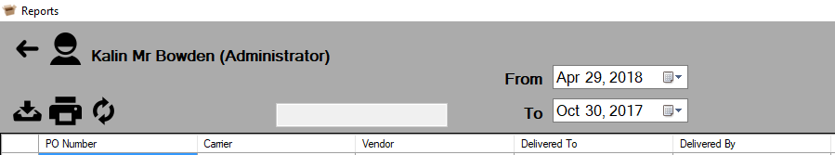

Search Dates

Refresh

Print

Add to Daily

**Adding a Package to the Daily Receiving List**

Sometimes you may find it necessary to add packages that were received in the past. To add a package(s) to the Daily Receiving List select the row(s) you wish to add and click the Add to Daily button (see fig 3.1).

**Printing History**

To print all or some of your package history, select the row(s) you wish to print. Click the print button (see fig 3.1). The Print Preview form will load (see fig 3.2). Review the selected packages and click print. Follow the onscreen print dialog for your computer.

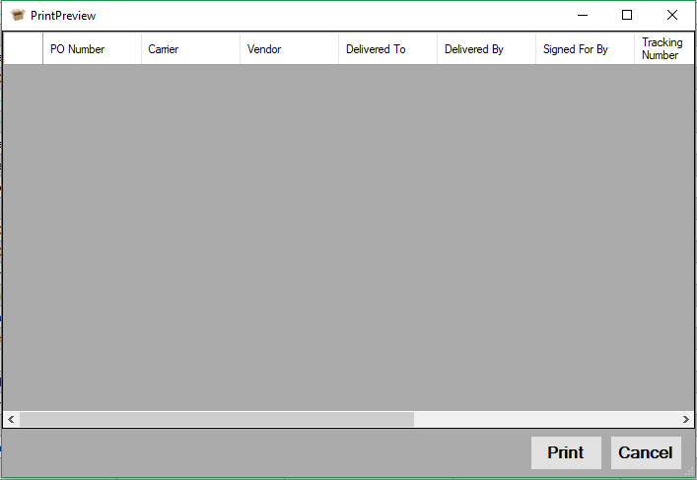

Fig 3.2

**Refreshing the Grid**

Should you experience a delay in the list updating or need to refresh the list, click the refresh button (see fig 3.1) to reload the list.

**Searching History**

To find packages more quickly you can filter packages by column. To do this, first double click the column you wish to filter by (see fig 3.1). A label will appear to indicate the selected column you are filtering by. In the search text box (see fig 3.1), type in the value you are looking for. The list will filter as it attempts to match the text you type in.

**MANAGE**

**Getting to Know the Manage Screen**

The Manage Screen is where you manage all the various data tables you use to track packages and create logs. It is also where you go to create and control Users and their access levels. What a user is allowed to do is determined by the role your user has been given.

Tables

Fig 4.1

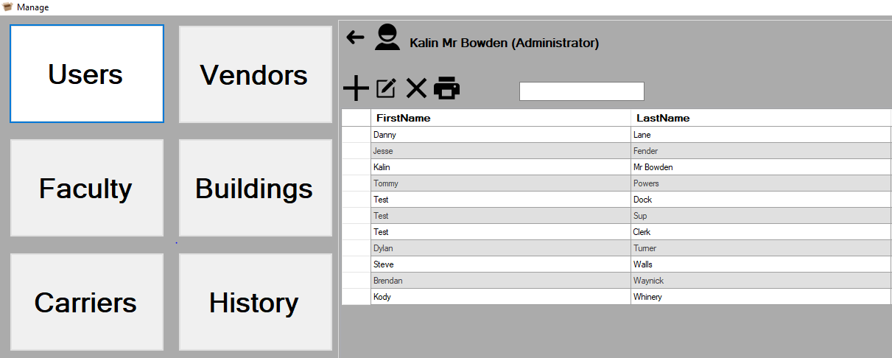

Fig 4.2

Back

Search Box

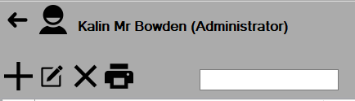

Print

Delete

Edit

Add

**Creating a User**

To create a user, first select the user table. Click the Add button. The Add User form will display (see fig 4.3). Fill out the form as indicated by the table. Click Add to create the user. It is important to note that the level you select for the user will determine what a user is allowed to do. The different roles are as follows.

**Roles:**

* Administrator:
  + Access to all forms and options.
* Dock-Supervisor:
  + Access to all forms except Settings.
  + May not delete Users.
* Supervisor:
  + Access to all forms except Settings.
  + View only access to Manage.
* Clerks:
  + Access only to Receiving as view only.

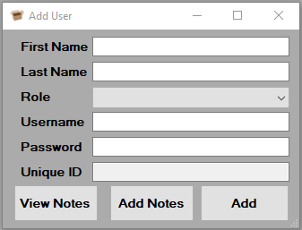

Fig 4.3

**Adding an Item to a List**

To add an Item to tables other than User, click the table you wish to add to. Once the grid has loaded click the Add button (see fig 4.2). An Add Form will display. Fill in the necessary fields. Click Add to add the item to the list

**Editing an Item in a List**

To edit an item in the list, click the table you wish to edit. Once the grid has loaded click the Edit button (see fig 4.2). An Edit Form will display. Fill in the necessary fields. Click the Edit button to update the item in the list.

**Deleting an Item in a List**

To Delete an Item in a list, Click the table you wish to delete from. Once the grid has loaded select the row you wish to delete and click the delete button (see fig 4.2). The item will be deleted.

**Printing a Table**

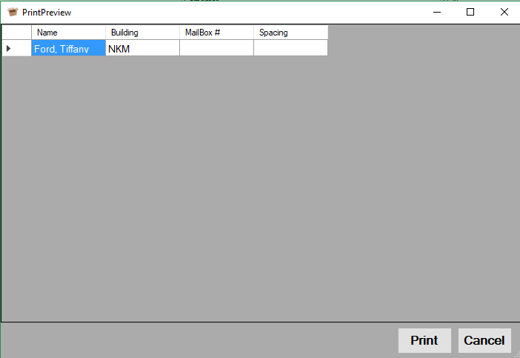To print items in a tables list, select the items you wish to print by highlighting the row(s) and press the print button (see fig 4.2). The print preview screen will appear (see fig 4.4). Check the data in the table and press the print button (see fig 4.4) and then follow your systems printing prompt instructions to print the list.

Fig 4.4

**Sorting a Table**

Sometimes it will be necessary to group like items by categories. You can do this easily in Manage by selecting the column you wish to sort by and clicking the column header (see fig 4.2). Columns are sorted alphanumerically from top to bottom. You can switch to bottom to top by clicking the Colum header once more.

**Searching a Table**

Filtering a table is similar to sorting a table. Double click the header of the column you wish to filter (see fig 4.2). The label above the search box (see fig 4.2) will display the column name. To filter a list type text into the search box and the list will display results with only data the contains the text typed.

**Using Notes**

**NOTES**

Sometimes you may find yourself with a package or other item that requires you too keep track of some piece of information that this application is not designed for. For this purpose, we added the ability to add notes to packages and a select few other items.

To add a note to a package or item, click the Add Note button in the Add/Edit package or item form. The Add Note form will display. Type in whatever information you wish to record and press the Add button.

When you need to view the note, or notes, you have added, simply click the View Note button in the Add/Edit package or item form. The View Note form will display with any notes that have been added.

**Note**: Once a note is added, it ***cannot*** be deleted. However, you may add as many notes to a package or item as needed.

**Getting to Know the Settings Menu**

**SETTINGS**

The Settings Menu allows you to control and change your database and connection settings.



Database Type

Save Connection

Fig 5.1

**Connecting to a Database**

The connection to the database is an important feature that will be required to install prior to the continued use of the application. The setup is straight forward, there are fields that represent the separate parts of the connection information: Host, Database Name, Database User, User Password, Port (if provided by database host) and the Database Type. These are all important parts of the connection to the database.

When establishing a new connection to your database ensure that all parts are entered correctly as specified by the database host provider (people who provide the database access). We strongly recommend that you test the connection to ensure that the connection settings are correct. For testing the new connection we have provided you with a test connection button, that will open a temporary connection to see if it was able to connect or not. When you have successfully connected you will receive a message box indicating that the connection is open, and you may save the new connection data to the settings. If the connection fails, you will note that it will take a bit longer to respond as it trys to connect. The message returned will be an error meaning that one or more settings are incorrect or that you have access issues beyond the scope of the application.

When you have successfully connected to the database, make sure that you click the save connection icon. This will save the connection string for later use by the application. The application will inform you that the connection string and information have been saved to the settings and that the application will then restart.

**Backing up the Database**

There are two back up features in the database, due to concerns of data being lost we have implemented an **automatic backup** as well as the ability for an admin or other authorized user to create a **manual backup** of the data in the database.

**Automatic Backup Schedule:** The database will automatically back up the database data any time an administrator logs into the application on a Tuesday or a Thursday. These files are just the data in the format for the server that the application is set to run from. They are stored in the application folder, Connections/Backup and will be identified by the date of the backup.   
**Note:** *You may want to clean the backup files every so often, or they will build up over time.*

**Manual Backups:** Manual backups are able to be run anytime so long as the user is authorized to do so (admins only). The purpose for this is to allow the user to set the database type that they will need the back up for (in case OTC requires them to move from one database to another). Currently we only support MSSQL and MySQL syntax. Select the database type and click the Backup button to process. This will start the process, and you may go on about your work.

**Restoring the Database**

In the event of a catastrophic failure of the database or if the database type has been changed you can recover the database data simply by first ensuring that you are connected to the database (if doing this along with setting up the new connection). Second, click the Restore button, select the backup file. Third, confirm that you have selected the file.

**Note:** *The backup must be in the correct format for the database that you are restoring to. If you are updating the database connection, make sure that you make a new backup prior to attempting the change, this is particularly important if the day falls on a Tuesday or a Thursday, if that is the case make sure to move the file outside the backup folder or it will be overwritten and you will lose all of the data.*

**Notes:_____________________________________________________________________________________________________________________________________________________________________________________________________________________________________________________________________________________________________________________________________________________________________________________________________________________________________________________________________________________________________________________________________________________________________________________________________________________________________________________________________________________________________________________________________________________________________________________________________________________________________________________________________________________________________________________________________________________________________________________________________________________________________________________________________________________________________________________________________________________________________________________________________________________________________________________________________________________________________________________________________________________________________________________________________________________________________________________________________________________________________________________________________________________________________________________________________________________________________________________________________________________________________________________________­­­­­­­­­­­­­­­_____________**